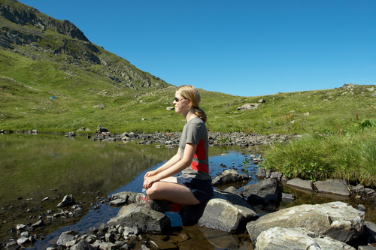
Sitting Meditation Exercises

Exercise 1
Sitting with the Breath
________________________________________________________________________

1. Continue to practice awareness of your breathing in a comfortable but erect sitting posture for at lease ten minutes at least once a day.
2. Each time you notice that your mind is no longer on your breath, just see where it is. Then let go and come back to your belly and to your breathing.
3. Over time try extending the time you sit until you can do it for thirty minutes or more. But remember, when you are really in the present, there is no time, so clock time is not as important as your willingness to pay attention and let go from moment to moment.
________________________________________________________________________

Exercise 2
Sitting with the Breath and the Body as a Whole
________________________________________________________________________

1. When your practice feels strong in the sense that you can maintain some continuity of attention on the breath, try expanding the field of your awareness “around” your body as a whole as you are sitting.
2. Maintain this awareness of the body sitting and breathing, and when the mind wanders, bring it back to the sitting and breathing.
________________________________________________________________________

Exercise 3
Sitting with Sound
________________________________________________________________________

1. If you feel like it, try just listening to sound when you meditate. This does not mean listening for sounds, rather just hearing what is here to be heard, moment by moment, without judging or thinking about them. Just hearing them as pure sound. And hearing the silences within and between sounds as well.
2. You can practice this with music, too, hearing each note as it comes and the spaces between notes. Try breathing the sounds into your body and letting them flow out again on the outbreath. Imagine that your body is transparent to sounds; that they can move in and out of your body through the pores of your skin.
________________________________________________________________________

Exercise 4
Sitting with Thoughts and Feelings
________________________________________________________________________

1. When your attention is relatively stable on the breath, try shifting your awareness to the process of thinking itself. Let go of the breath and just watch thoughts come into and leave the field of your attention.
2. Try to perceive them as “events” in your mind
3. Note their content and their charge while, if possible, not being drawn into thinking about them, or thinking the next thought, but just maintaining the “frame” through which you are observing the process of thought.
4. Note that an individual thought does not last long. It is impermanent. If it comes, it will go. Be aware of this.
5. Note how some thoughts keep coming back.
6. Note those thoughts that are “I”, “me”, or “mine” thoughts, observing carefully how “you”, the non-judging observer, feel about them.
7. Note it when the mind creates a “self” to be preoccupied with how well or how badly your life is going.
8. Note thoughts about the past and thoughts about the future.
9. Note thoughts that are about greed, wanting, grasping, clinging.
10. Note thoughts that are about anger, disliking, hatred, aversion, rejection.
11. Note feelings and moods as they come and go.
12. Note what feelings are associated with different thought contents.
13. If you get lost in all this, just go back to your breathing.

This exercise requires great concentration and should only be done for short periods of
time, like two to three minutes per sitting in the early stages.
________________________________________________________________________

Exercise 5
Sitting with Choiceless Awareness
________________________________________________________________________

1. Just sit. Don’t hold on to anything, don’t look for anything. Practice being completely open and receptive to whatever comes into the field of awareness, letting it all come and go, watching, witnessing in stillness.
________________________________________________________________________

From ‘Full Catastrophe Living’ Jon Kabat-Zinn

